EC-200 Data Structures

Lab Manual 13

**Course Instructor:** Lecturer Anum Abdul Salam

**Lab Engineer:** Lab Engineer Ayesha Batool

**Student Name: _______________________________________________**

**Degree/ Syndicate: ____________________________________________**

|  |  |  |  |
| --- | --- | --- | --- |
|  | **Trait** | **Obtained Marks** | **Maximum Marks** |
| **R1** | **Application Functionality 20%** |  | 20 |
| **R2** | **Specification & Data structure implementation**  **30%** |  | 30 |
| **R3** | **Reusability**  **10%** |  | 10 |
| **R4** | **Input Validation**  **10%** |  | 10 |
| **R5** | **Efficiency**  **20%** |  | 20 |
| **R6** | **Delivery**  **10%** |  | 10 |
| **R7** | **Plagiarism above 80%** |  | 1 |
|  | **Total** |  | 10 |

**Total Marks = O**𝒃𝒕𝒂𝒊𝒏𝒆𝒅 𝑴𝒂𝒓𝒌𝒔 (∑6𝟏 𝑹𝒊 ∗ 𝑹7)

# Lab Manual # 13: Searching And Sorting Algorithms

## Lab Objective:

To Implement searching and sorting algorithms and analyze their time complexity

## Lab Description:

### Selection Sort

Selection sort is a simple sorting algorithm. This sorting algorithm is an in-place comparison-based algorithm in which the list is divided into two parts, the sorted part at the left end and the unsorted part at the right end. Initially, the sorted part is empty and the unsorted part is the entire list. The smallest element is selected from the unsorted array and swapped with the leftmost element, and that element becomes a part of the sorted array. This process continues moving unsorted array boundary by one element to the right. Consider the following depicted array as an example.

Unsorted Array

For the first position in the sorted list, the whole list is scanned sequentially. The first position where 14 is stored presently, we search the whole list and find that 10 is the lowest value.

Selection Sort

So we replace 14 with 10. After one iteration 10, which happens to be the minimum value in the list, appears in the first position of the sorted list.

Selection Sort

The same process is applied to the rest of the items in the array.

### Bubble Sort

Bubble sort is a simple sorting algorithm. This sorting algorithm is comparison-based algorithm in which each pair of adjacent elements is compared and the elements are swapped if they are not in order. We take an unsorted array for our example.

Bubble Sort

Bubble sort starts with very first two elements, comparing them to check which one is greater.

Bubble Sort

In this case, value 33 is greater than 14, so it is already in sorted locations. Next, we compare 33 with 27.

Bubble Sort

We find that 27 is smaller than 33 and these two values must be swapped.

Bubble Sort

The new array should look like this

Bubble Sort

Next we compare 33 and 35. We find that both are in already sorted positions.

Bubble Sort

Then we move to the next two values, 35 and 10.

Bubble Sort

We know then that 10 is smaller 35. Hence they are not sorted.

Bubble Sort

We swap these values. We find that we have reached the end of the array. After one iteration, the array should look like this

Bubble Sort

To be precise, we are now showing how an array should look like after each iteration. After the second iteration, it should look like this

Bubble Sort

Notice that after each iteration, at least one value moves at the end.

Bubble Sort

And when there's no swap required, bubble sorts learns that an array is completely sorted.

Bubble Sort

### Insertion Sort

This is an in-place comparison-based sorting algorithm. Here, a sub-list is maintained which is always sorted. For example, the lower part of an array is maintained to be sorted. An element which is to be 'insert’ed in this sorted sub-list, has to find its appropriate place and then it has to be inserted there. Hence named **insertion sort**. The array is searched sequentially and unsorted items are moved and inserted into the sorted sub-list (in the same array).

### Linear Search

Linear search is a very simple search algorithm. In this type of search, a sequential search is made over all items one by one. Every item is checked and if a match is found then that particular item is returned, otherwise the search continues till the end of the data collection.

### Binary Search

This search algorithm works on the principle of divide and conquer. For this algorithm to work properly, the data collection should be in the sorted form. Binary search looks for a particular item by comparing the middle most item of the collection. If a match occurs, then the index of item is returned. If the middle item is greater than the item, then the item is searched in the sub-array to the left of the middle item. Otherwise, the item is searched for in the sub-array to the right of the middle item. This process continues on the sub-array as well until the size of the subarray reduces to zero. For a binary search to work, it is mandatory for the target array to be sorted. We shall learn the process of binary search with a pictorial example. The following is our sorted array and let us assume that we need to search the location of value 31 using binary search.

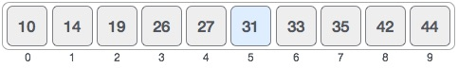

First, we shall determine half of the array by using this formula

mid = low + (high - low) / 2

Here it is, 0 + (9 - 0 ) / 2 = 4 (integer value of 4.5). So, 4 is the mid of the array.

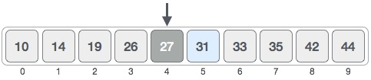

Now we compare the value stored at location 4, with the value being searched, i.e. 31. We find that the value at location 4 is 27, which is not a match. As the value is greater than 27 and we have a sorted array, so we also know that the target value must be in the upper portion of the array.

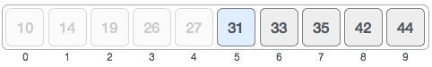

We change our low to mid + 1 and find the new mid value again.

low = mid + 1

mid = low + (high - low) / 2

Our new mid is 7 now. We compare the value stored at location 7 with our target value 31.

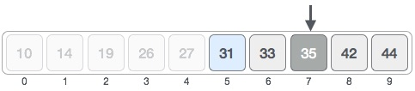

The value stored at location 7 is not a match, rather it is less than what we are looking for. So, the value must be in the lower part from this location.

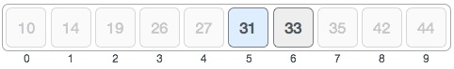

Hence, we calculate the mid again. This time it is 5.

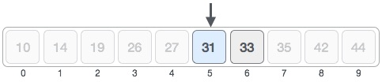

We compare the value stored at location 5 with our target value. We find that it is a match.

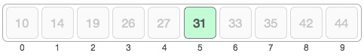

We conclude that the target value 31 is stored at location 5. Binary search halves the searchable items and thus reduces the count of comparisons to be made to very less numbers.

## LAB TASKS

1. Implement all the above searching and sorting algorithms and compute their complexity.

### TIME COMPLEXITY:

**Fill the following table for each algorithm**

|  |  |  |  |
| --- | --- | --- | --- |
| **Sr.** | **Algorithms** | **Complexity** | **Remarks** |
| **1.** | Bubble Sort |  |  |
| **2.** | Insertion Sort |  |  |
| **3.** | Selection Sort |  |  |
| **4.** | Merge Sort |  |  |
| **5.** | Radix Sort |  |  |
| **6.** | Quick Sort |  |  |
| **7.** | Linear Search |  |  |
| **8.** | Binary Search |  |  |

**THINK?**

1. Which Searching algorithm is better? Explain why?
2. Which Sorting algorithm is better?
3. What is the prerequisite for applying binary search?